# INTRODUCTION

A flying object can have some emergency scenarios in which it is needed to be landed in emergency so that it is basically required to know whether the land area is capable of landing or not and for selecting of particular reason of interest at which the object needed to be identified for safe landing in real time. Image object detection is a process of identifying and locating objects in an image using computer algorithms and machine learning.

This technique is widely used in various applications such as surveillance, autonomous vehicles, medical imaging, and robotics. Object detection algorithms can be classified into different types, including template matching, edge detection, and feature-based methods. The choice of algorithm depends on the specific application and the characteristics of the images being analyzed. Object detection is an essential tool in image processing that enables computers to better understand and interpret visual information. With the advancement of technology, we can expect to see even more advanced object detection techniques being developed and applied in various fields.

For example, in surveillance applications, image object detectors can be used to detect and track people or vehicles in real-time, enabling the drone to follow them and gather more information. In mapping applications, object detection can be used to identify and locate landmarks, buildings, and other objects that need to be mapped. In inspection applications, object detection can be used to detect defects or anomalies in structures such as bridges, power lines, and pipelines.

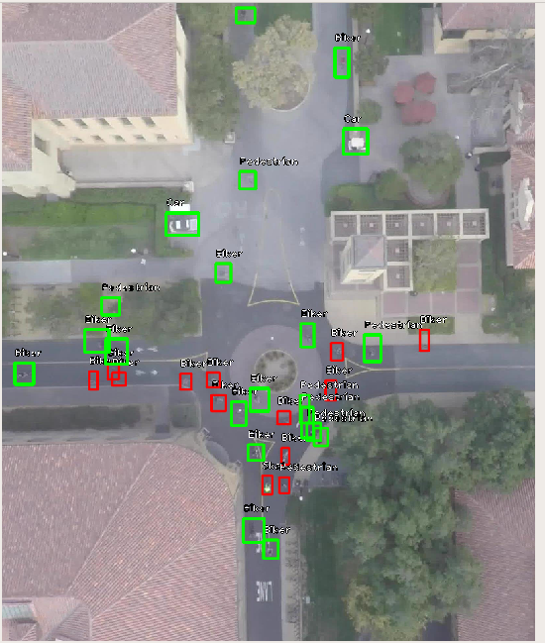

Figure 1: Image of detection and identification

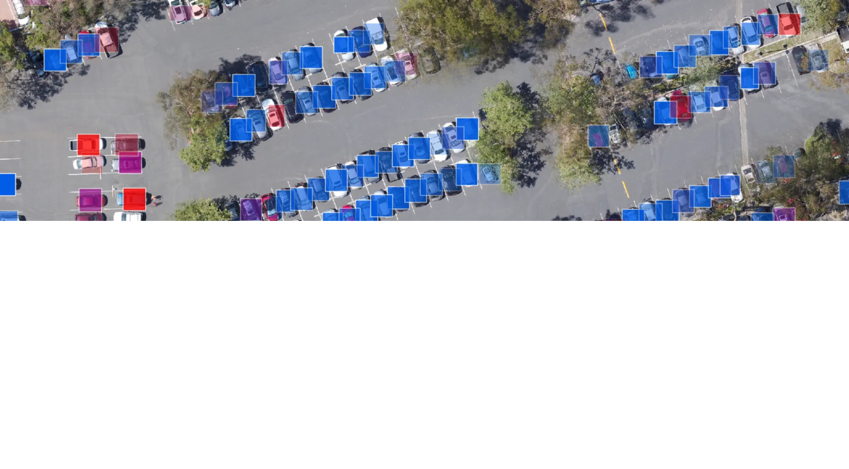

Figure 2: Masking on Images

# LITERATURE SURVEY

# 2.1 An intelligent real-time object detection system on drones et al.

In this paper, Drones have been widely used in everyday life and they can help deal with various tasks, including photography, searching, and surveillance. it is difficult for drones to perform customized online real-time object detection. In this study, we propose an intelligent real-time object detection system for drones.  It is composed of an FPGA and a drone. A neural-network (NN) engine is designed on the FPGA for NN model acceleration. The FPGA receives activation data from an NN model, which are assembled into the data stream.  By using the Yolov3-tiny model for fast object detection, our system can detect objects at the speed of 8 frames per second and achieves a much lower power consumption compared to state-of-the-art methods. More importantly, the intelligent object detection techniques provide more pixels for the target of interest and they can increase the detection confidence score from 0.74 to 0.90 and from 0.70 to 0.84 for persons and cars, respectively.**[1]**

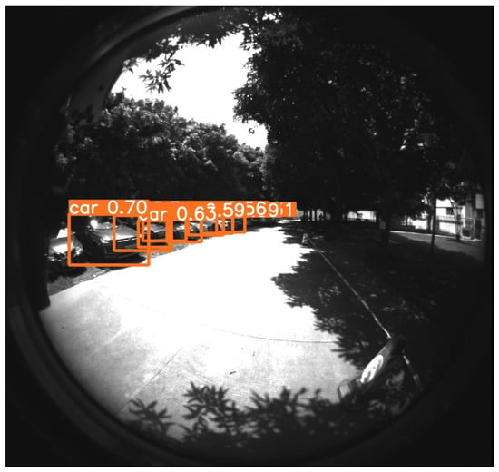

Figure 3: The ordinary car-detection result.

# 2.2 Sky Monitoring System for Flying Object Detection Using 4K Resolution Camera et al.

In this paper, The use of drones and other unmanned aerial vehicles has expanded rapidly in recent years. These devices are expected to enter practical use in various fields, such as taking measurements through aerial photography and transporting small and lightweight objects. In particular, with the recent progress of deep neural network technology, the monitoring of systems using image processing has been proposed. This study developed a monitoring system for flying objects using a 4K camera and a state-of-the-art convolutional neural network model to achieve real-time processing. We installed a monitoring system in a high-rise building in an urban area during this study and evaluated the precision with which it could detect flying objects at different distances under different weather conditions. The results obtained provide important information for determining the accuracy of monitoring systems with image processing in practice.**[2]**

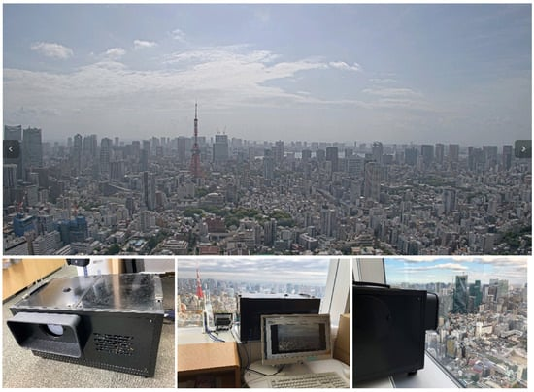

Figure 4: Image captured by the monitoring system and system installation. [2]

# METHODOLOGY

Step-1: Take ESP32 with cam and connected with Arduino

Step-2: Using CAM in ESP32 and store in a memory card. And then data of video will be taken from memory card.

Step-3: Take entire system to top by using any fly machine like balloons or drone.

Step-4: Data collected will be processed by using OpenCV2 module and the features will be redrived and all required features will be extracted.

Step -5: Now we will create a machine learning model by a Linear recursion Algorithm

Step-6: Machine learning algorithms required data. Data of features of and there classification. We are using persons, mountains, rivers, buildings, cars and motor vehicles, trucks etc.

Step-7: Now based on features a bounding box is created and labelled it with the particular object.

Step-8: As we will get the video with bounding box and labelled.

# COMPONENTS OF OBJECT DETECTOR

The Object Detector can be designed using hardware components as well as software components.

**4.1 HARDWARE COMPONENTS:**

The hardware components that are used in the preparation of the quadcopter

* ESP32-S
* Memory card
* Balloons
* Own drone or Any flying object

**4.2 SOFTWARE:**

The software components that are used in the preparation of the quadcopter

* Arduino
* ESP-32 board configuration
* Google collab
* Data sets of images and their classification

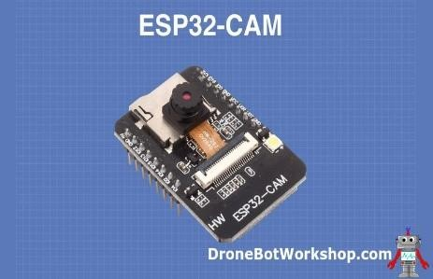

Figure 5: Esp32-S

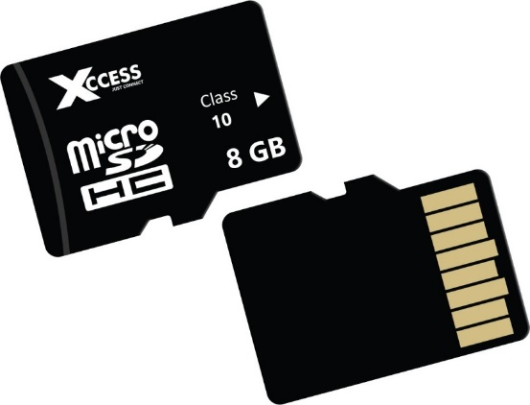

Figure 6: Memory card

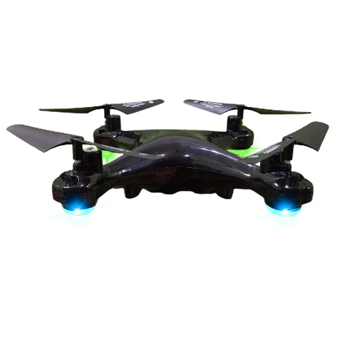

Figure 7: Drone

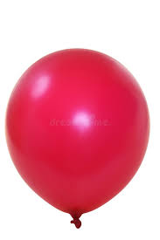

Figure 8: Ballon

# 5.ADVANTAGES AND DISADVANTAGES OF OBJECT DETECTOR

**5.1 Advantages:**

1.Can detect a wide range of objects, including animals, vehicles, and other non-human entities.

2. Can detect multiple objects within a single image or video

3. By detecting and avoiding obstacles in the environment, image object detectors can help ensure the safety of both the flying machine and the surrounding area.

4. Image object detectors use advanced algorithms to accurately identify and locate objects in real-time.

**5.2 Disadvantages:**

1.May require more complex algorithms to accurately identify different types of objects.

2. Image object detectors may struggle to accurately detect objects in certain conditions, such as low light or adverse weather conditions.

**5.3 Applications:**

There are so many applications like in Traffic Management and vehicle detection retail, Inventory management, Urban planning and Infrastructure, Agriculture etc.

1.In Security and surveillance

2.Environmental Monitoring

# 6. REFERENCES

[1] William Metzler, Daniel Pinson, Austen Hendrickson, (8 April 2021). Low-Cost Drone System for Analyzing Elevation. *IEEE* *Richard Xu and Justin Henriques James Madison University.*

[2] Seyit Alperen CELTEK, (18 May 2019). Design and Simulation of the Hierarchical Tree Topology Based Wireless Drone Network.*IEEE Department of Energy Engineering Karamanaglu*

*Mehmetbey University Karaman,Turkey.* https://doi.org/10.1109/ICOT54518.2021.9680627/

[3[]](https://cfdflowengineering.com/working-principle-and-components-of-drone/) Epfl.ch-labs,cvlab,research-uav-research-unmanned-detection- accessed on 30/10/2023

[4][Electronicsforu-electronics](https://www.electronicsforu.com/electronics)[-projects-low-cost-drone-powered-by-esp32](https://www.electronicsforu.com/electronics-projects/low-cost-drone-powered-by-esp32-cam/%20accessed%20on%2015/5/2023) [accessed on 15/5/2023](https://www.electronicsforu.com/electronics-projects/low-cost-drone-powered-by-esp32-cam/%20accessed%20on%2015/5/2023)

[5] [Instructables, Arduino](https://www.instructables.com/Arduino)[-micro](https://www.instructables.com/Arduino-micro-Quadcopter/) accessed on 16/5/2023

[6][researchgate.net-publication-357247011-figure-fig1-AS:1104177048621168@](https://www.researchgate.net/publication/357247011/figure/fig1/AS:1104177048621168@)[16 40267731913/Some-components-of-the-ESP32-CAM-camera-b-piezoelectric-sensor](https://www.researchgate.net/publication/357247011/figure/fig1/AS:1104177048621168@1640267731913/Some-components-of-the-ESP32-CAM-camera-b-piezoelectric-sensor-and-c.jpg%20/%20accessed%20on%2016/5/2023)  [accessed on 30/10/2023](https://www.researchgate.net/publication/357247011/figure/fig1/AS:1104177048621168@1640267731913/Some-components-of-the-ESP32-CAM-camera-b-piezoelectric-sensor-and-c.jpg%20/%20accessed%20on%2016/5/2023)